Sri Lanka Institute of Information

Technology



Lab Submission

<Lab sheet No 05>

**<IT24101668>**

**<Nanayakkara N N D A S>**

**Probability and Statistics | IT2120**

Exercise

1.Import the dataset (’Exercise – Lab 05.txt’) into R and store it in a data frame called ”Delivery Times”.

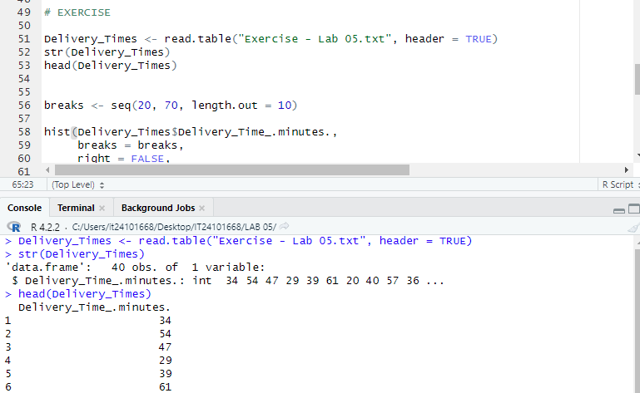

2. Draw a histogram for deliver times using nine class intervals where the lower limit is 20 and upper limit is 70. Use right open intervals.

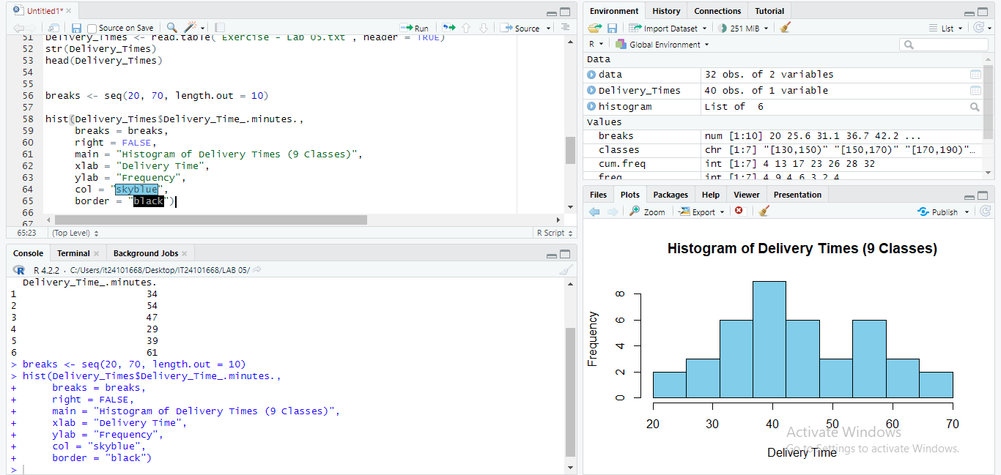

3.Comment on the shape of the distribution.

The distribution is approximately unimodal, slightly skewed to the right (positively skewed), since more values are clustered in the lower-middle ranges with a tail extending to higher times.

4.Draw a cumulative frequency polygon (ogive) for the data in a separate plot.

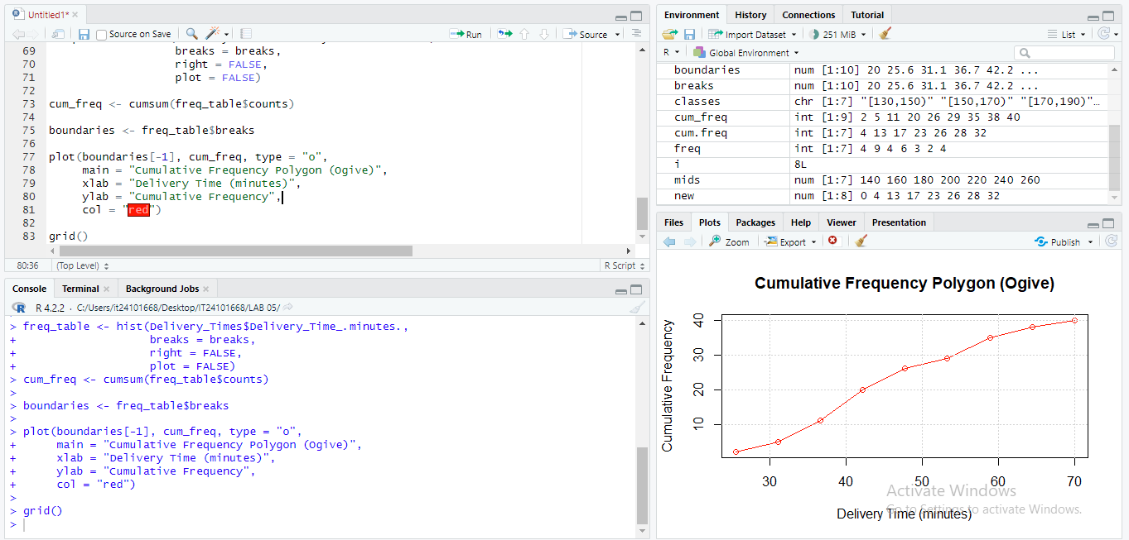

**Lab Exercise 5 (Descriptive Statistics)** The numbers of shareholders for a selected of large companies (in thousands) are given below.

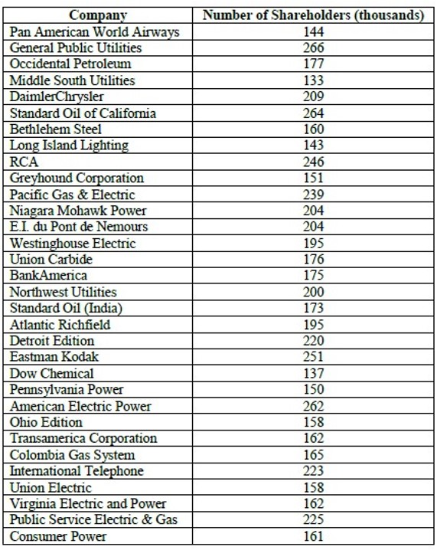

Before starting the lab sheet, you need to create a folder in your desktop and save all your working inside the folder. Set the working directory to that folder using the following command:

setwd("paste the path of the folder")

**Eg:-** setwd("D:\\2025 - Sem 2\\IT2120\\Lab Sessions\\Lab 05") The number of shareholders is to be organized into a frequency distribution.

1. 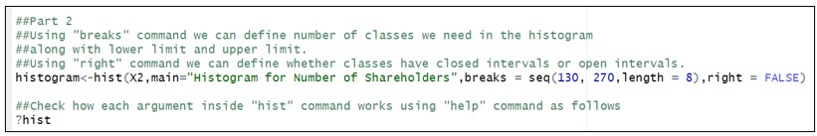Draw a histogram for the above data.

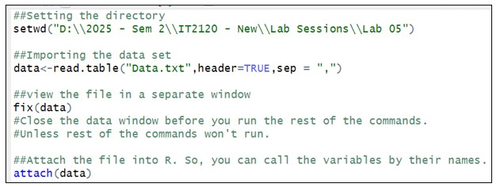

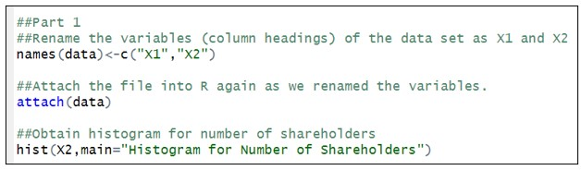

1. Draw a histogram using seven classes where the lower limit is 130 and an upper limit of 270.
2. Construct the frequency distribution for the above specification.

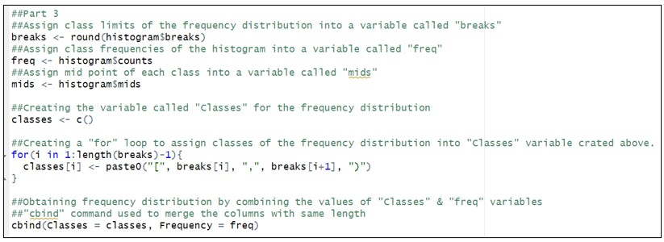

1. Portray the distribution in the form of a frequency polygon.

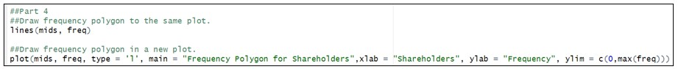

1. Portray the distribution in a cumulative frequency polygon (ogive).

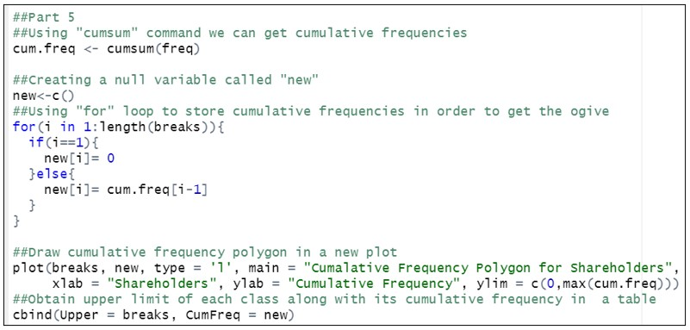

Part 1

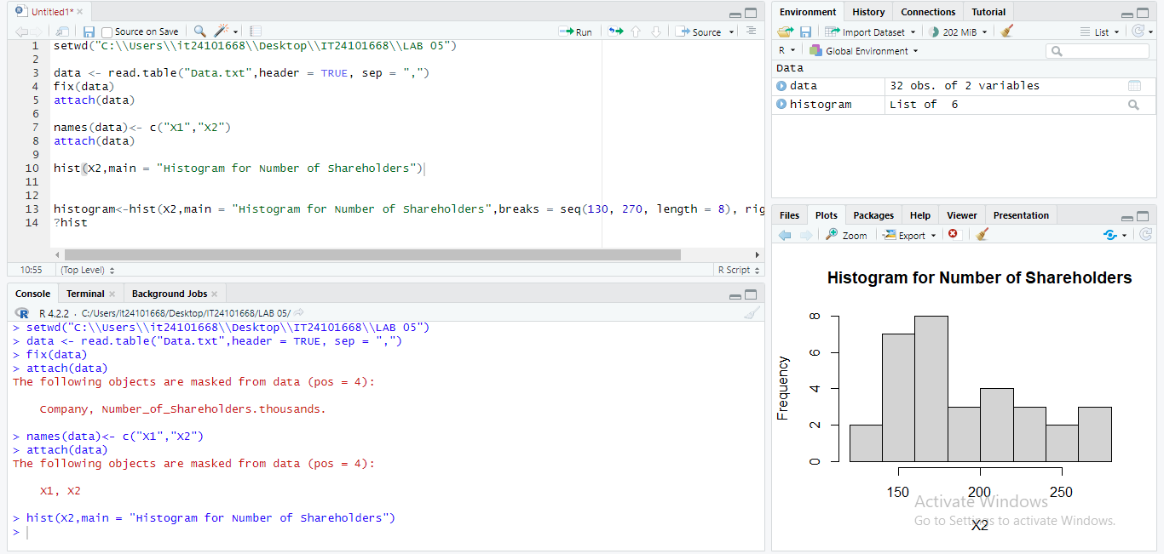

Part 2

1. 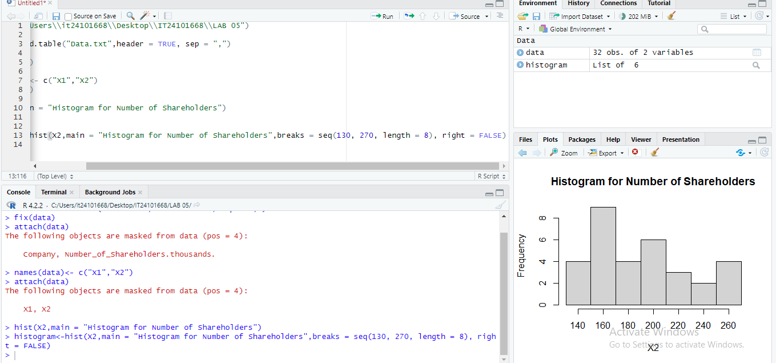

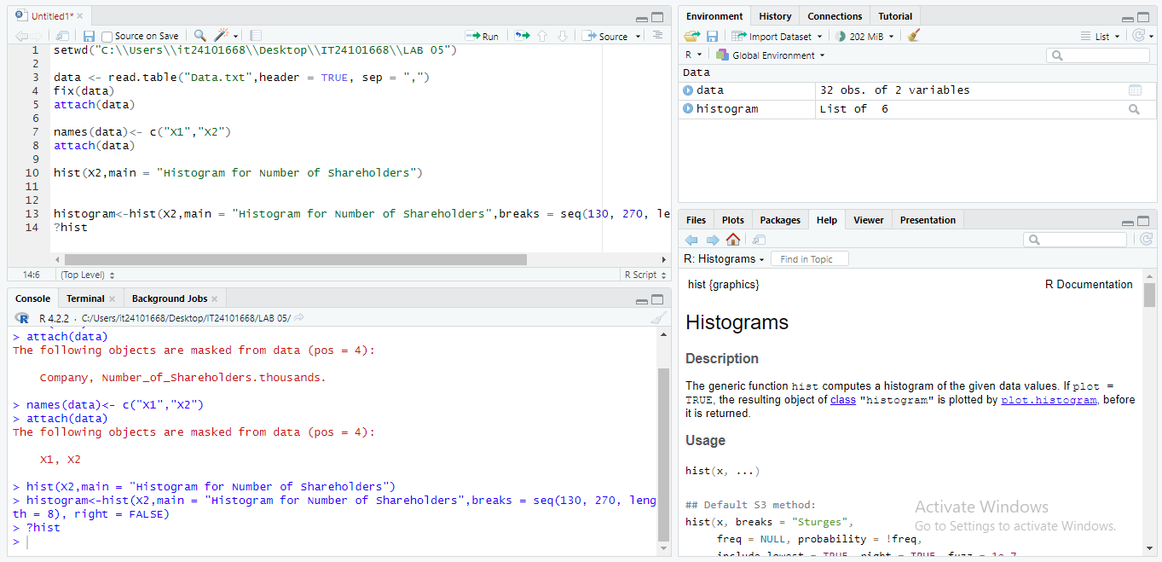

Part - 3

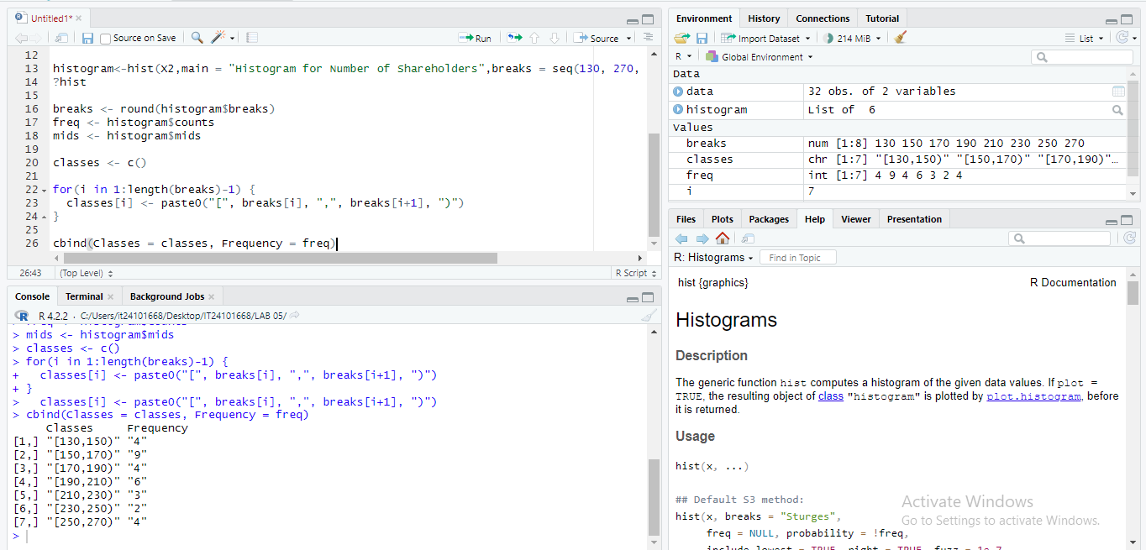

Part – 4

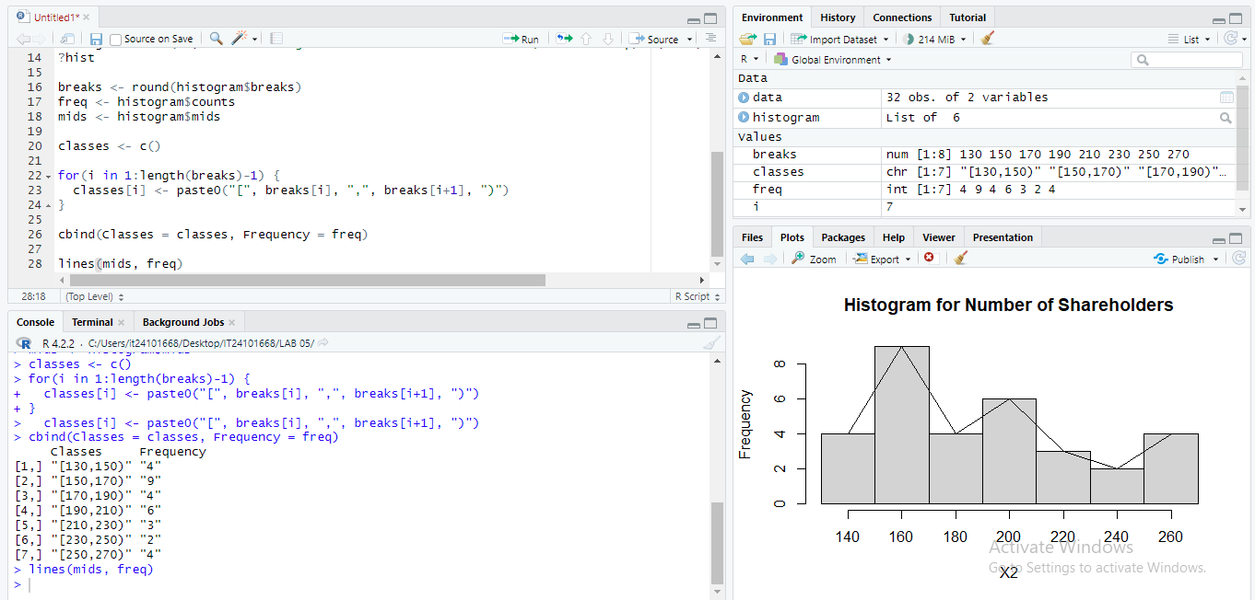

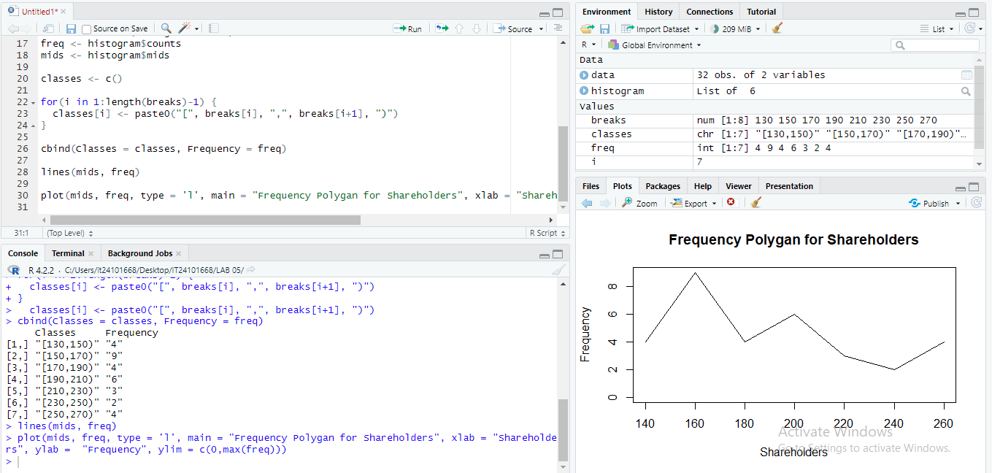

Part – 5

